To build the application as per this version, you need to follow the below instruction.

1. This version will implement the **Notifications** library that is a part of Android Jetpack.
2. To generate the Notification icon. Go to the Android Studio and click on **File -> New -> Image Asset.**

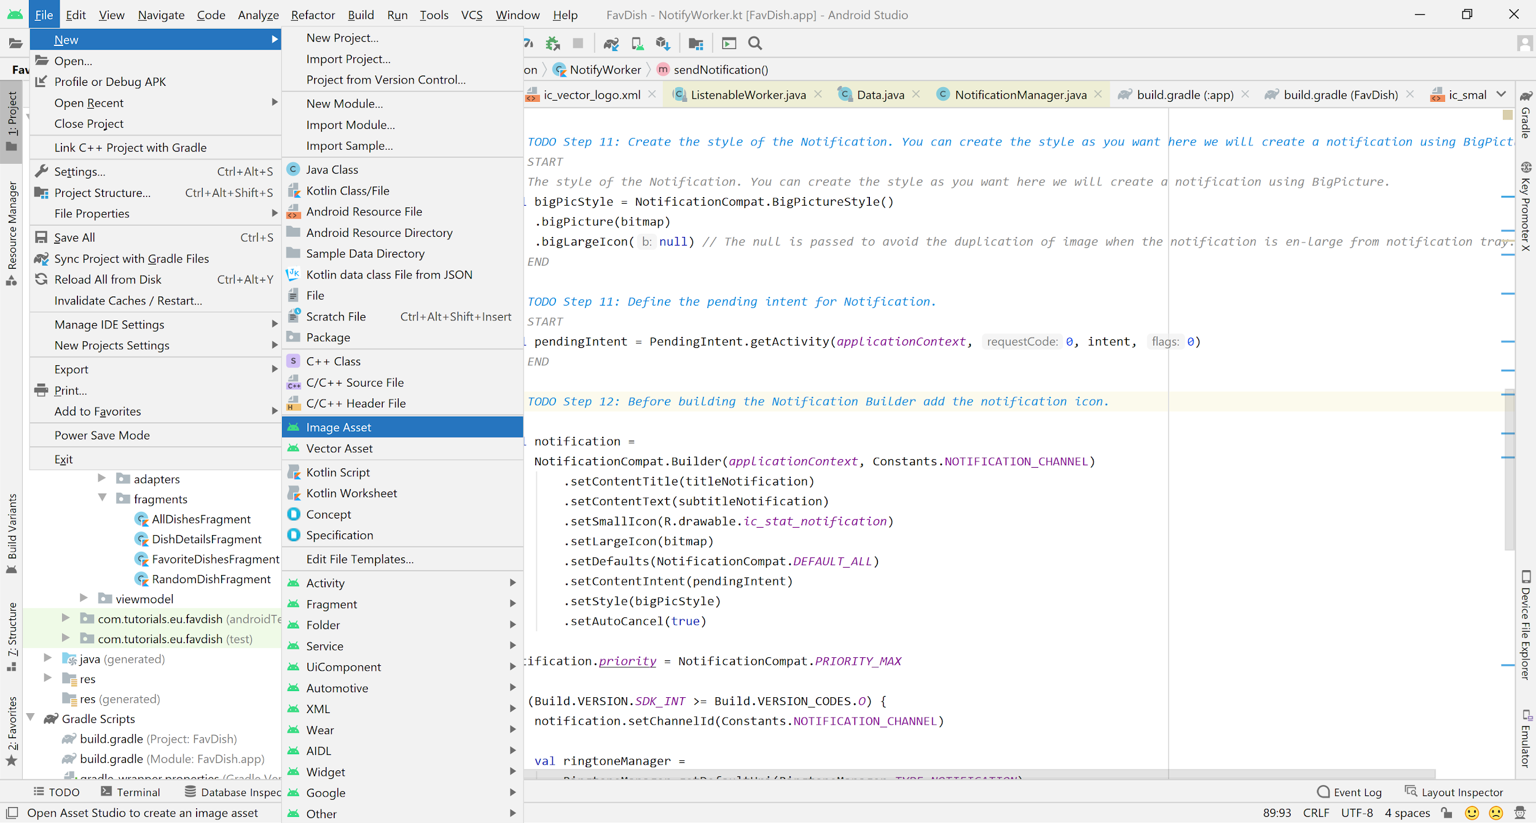

1. Below is the image that we will generate as a Notification icon.



1. Now you have the icon.
2. Select the notification icon using Image Asset as below.

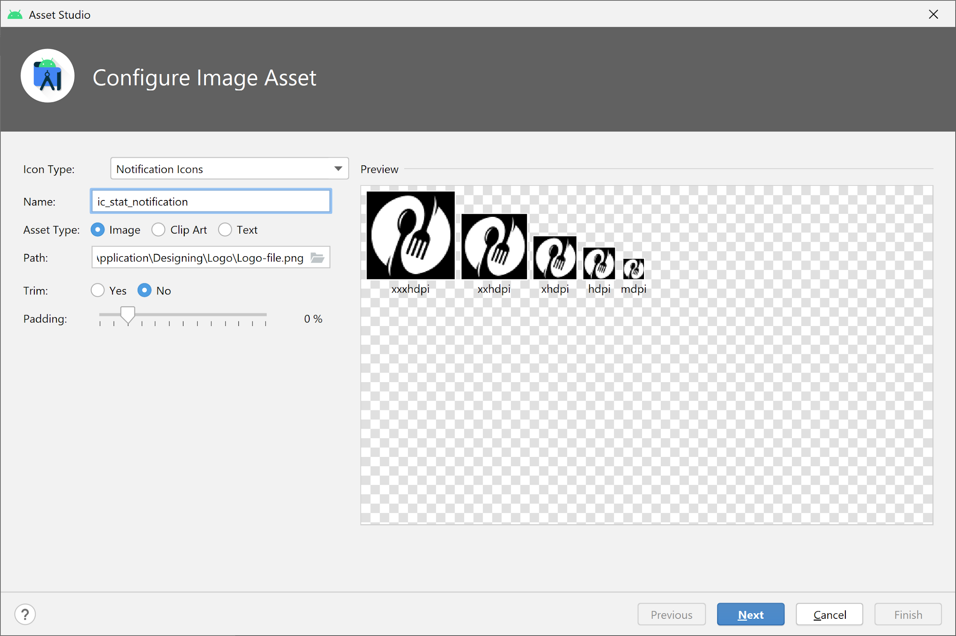

1. Click on Next.

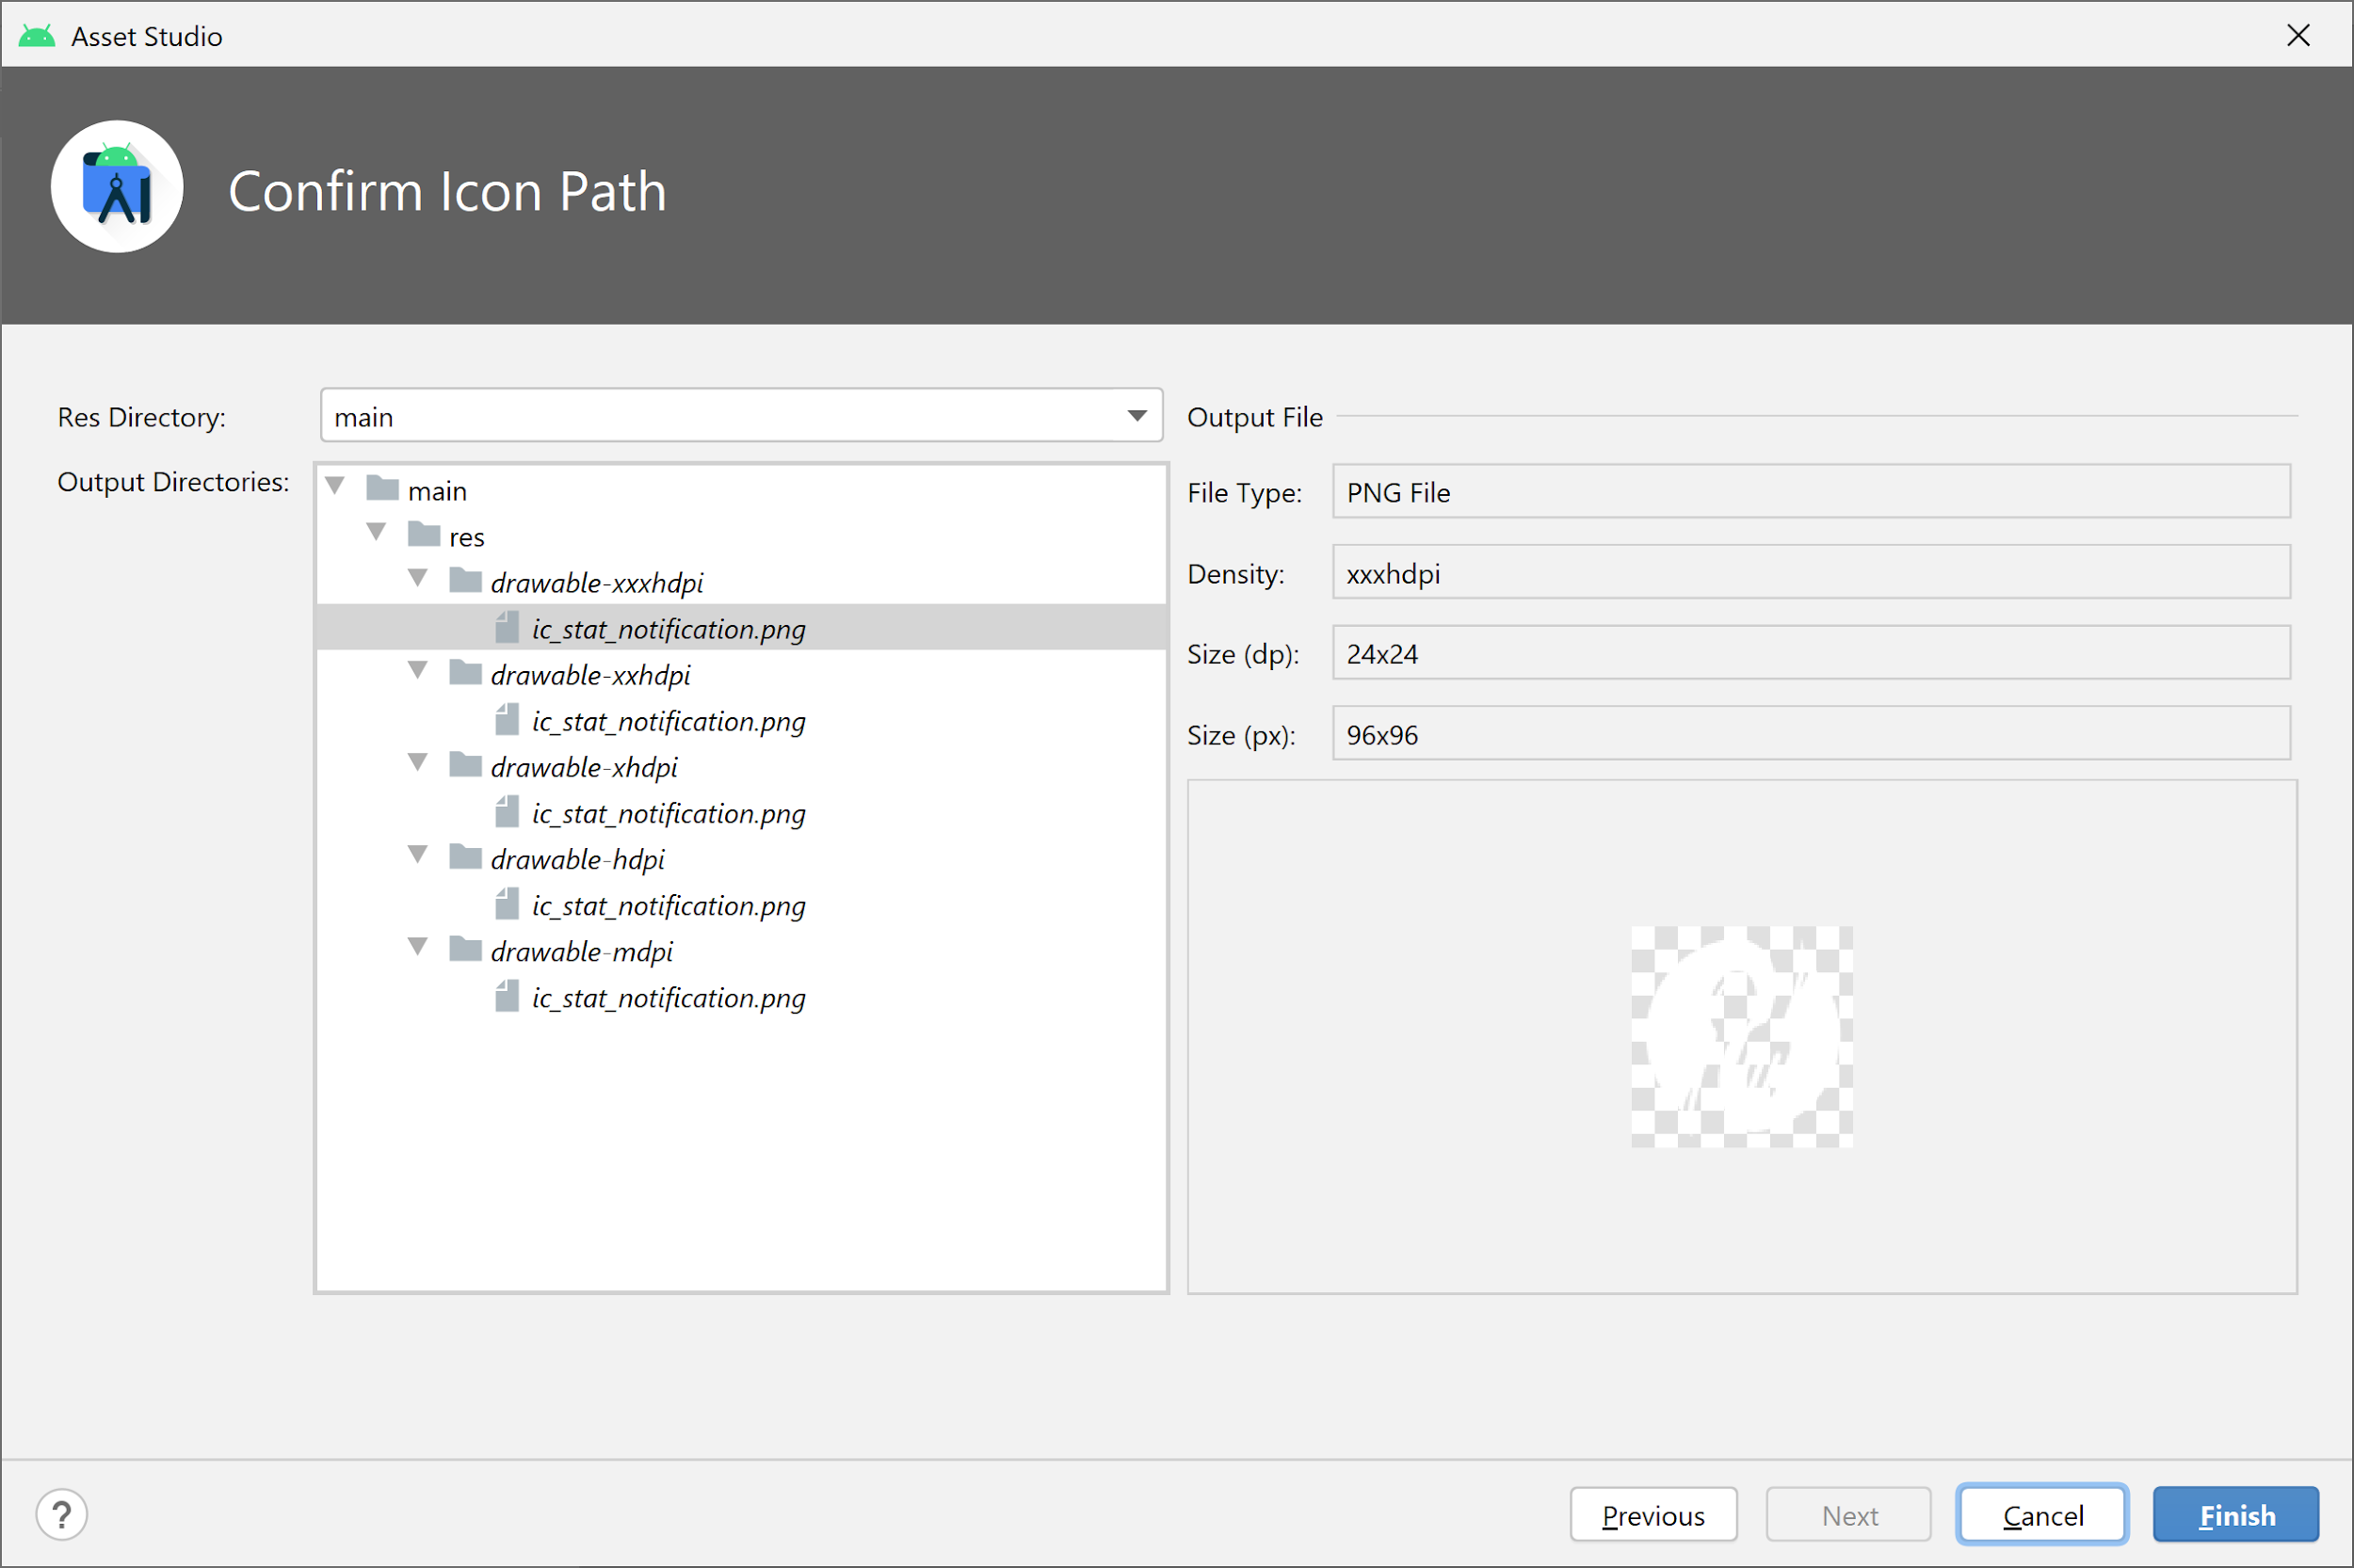

1. Click on Finish and you are done with icon generation.
2. Follow the TODO steps of the app.
3. Enjoy!!!

Reference Links:

<https://developer.android.com/guide/topics/ui/notifiers/notifications#:~:text=A%20notification%20is%20a%20message,action%20directly%20from%20the%20notification>.

